**PRACTICAL – 5(5.1)**

**AIM:**

**Write a program to generate a random number between 1 and 9 (including 1 and 9). Ask the user to guess the number, then tell them whether they guessed too low, too high, or exactly right. (Hint: remember to use the user input lessons from the very first practical)**

|  |
| --- |
|  |

**PROGRAM:**

|  |
| --- |
| **from random import randrange**  **a = int(input("Enter user defined number: "))**  **rd = int(input("Random Number: "))**  **if(a > rd):**  **print("It's a high number.")**  **elif(a < rd):**  **print("It's a low number.")**  **else:**  **print("Exactly Same")**  **print("\n20DCE019 - Yatharth Chauhan")** |

**OUTPUT:**

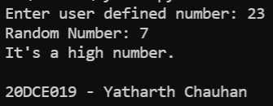

**CONCLUSION:** In this practical I have learned about random library file

**PRACTICAL – 5(5.2)**

**AIM:**

**Write a program to generate a random number between 1 and 9 (including 1 and 9). Ask the user to guess the number, then tell them whether they guessed too low, too high, or exactly right. (Hint: remember to use the user input lessons from the very first practical)**

|  |
| --- |
|  |

**PROGRAM:**

|  |
| --- |
| **a = [1, 1, 2, 3, 5, 8, 13, 21, 34, 55, 89]**  **a = (set(a))**  **b = [1, 2, 3, 4, 5, 6, 7, 8, 9, 10, 11, 12, 13]**  **b = (set(b))**  **ans = a & b**  **print(str(ans))**  **print("\n20DCE019 - Yatharth Chauhan")** |

**OUTPUT:**

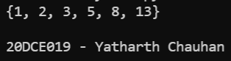

**CONCLUSION:** In this practical I have learned about random library file.